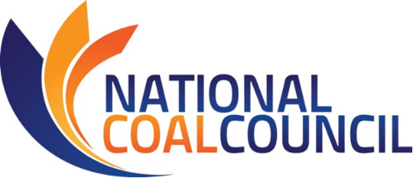
Webcast on NCC Reports
October 1st, 2018 – 11:30 am-1 pm Eastern

FINAL AGENDA

Monday, October 1st, 2018
U.S. Department of Energy – National Coal Council – Federal Advisory Committee Meeting

11:30 – 11:40 am CALL TO ORDER/OPENING REMARKS
Joseph Giove, NCC Deputy Designated Federal Officer
Director Coal Business Operations
Office Fossil Energy, U.S. Department of Energy

11:40 am – 12:10 pm NCC REPORT PRESENTATION & NCC MEMBERSHIP VOTE
Advancing U.S. Coal Exports:
An Assessment of Opportunities to Enhance Exports of U.S. Coal
Report Co-Chairs:
Justin Burk, Commercial Director, Peabody
David Lawson, Vice President Coal, Norfolk Southern Corporation

12:10 – 12:45 pm NCC REPORT PRESENTATION & NCC MEMBERSHIP VOTE
Power Reset:
Optimizing the Existing Coal Fleet to Ensure a Reliable & Resilient Power Grid
Janet Gellici, CEO, National Coal Council

12:45 – 1:00 pm PUBLIC COMMENT PERIOD & CLOSING REMARKS
1:00 pm ADJOURN

Revision: September 11, 2018

