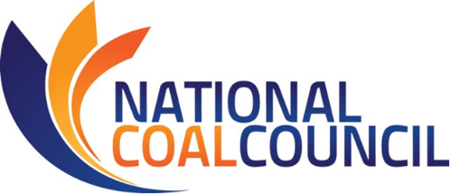

Webcast on NCC Report
COAL POWER: Smart Policies in Support of Stronger, Cleaner Energy
July 16th, 2020 – Noon-1 pm Eastern

AGENDA

U.S. Department of Energy – National Coal Council – Federal Advisory Committee Meeting

12:00 – 12:10 pm CALL TO ORDER/OPENING REMARKS/ANTI-TRUST ADVISORY
Thomas A. Sarkus, NCC Deputy Designated Federal Official
Industrial Partnerships Manager
National Energy Technology Laboratory, U.S. Department of Energy

12:10 – 12:40 pm NCC REPORT PRESENTATION
COAL POWER: Smart Policies in Support of Stronger, Cleaner Energy
Janet Gellici, CEO, National Coal Council, Inc.

12:40 – 12:45 pm NCC MEMBERSHIP VOTE

12:45 – 12:55 pm PUBLIC COMMENT PERIOD & CLOSING REMARKS

12:55 pm ADJOURN

Revision: July 1, 2020

